**Create a new React Application with the name “myfirstreact”, Run the application to print “welcome to the first session of React” as heading of that page.**

1. To create a new React app, Install Nodejs and Npm from the following link:

<https://nodejs.org/en/download/>

**Output:**  
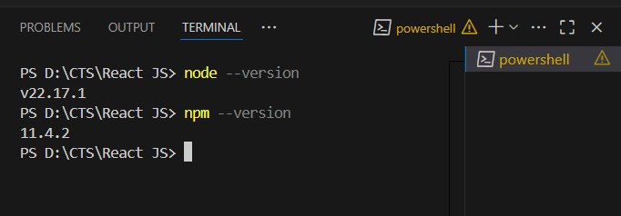

1. Install Create-react-app by running the following command in the command prompt:

**npm install -g create-react-app**

**Output:**

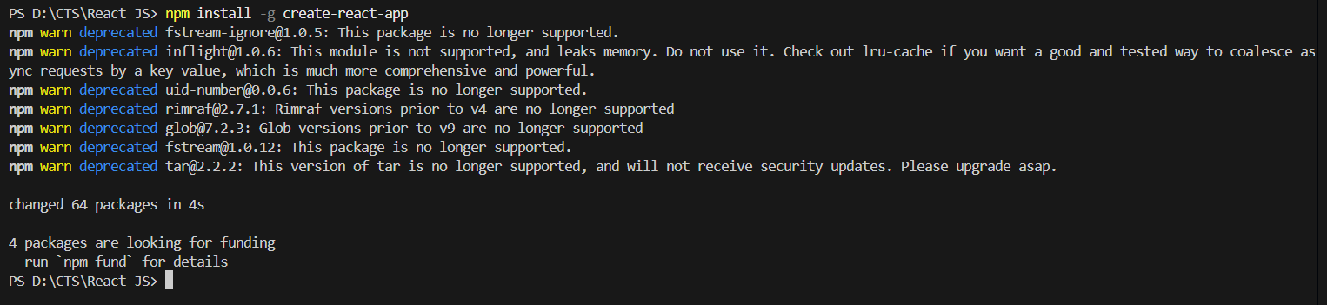

1. To create a React Application with the name of “myfirstreact”, type the following command:

**npx create-react-app myfirstreact**

**Output:**

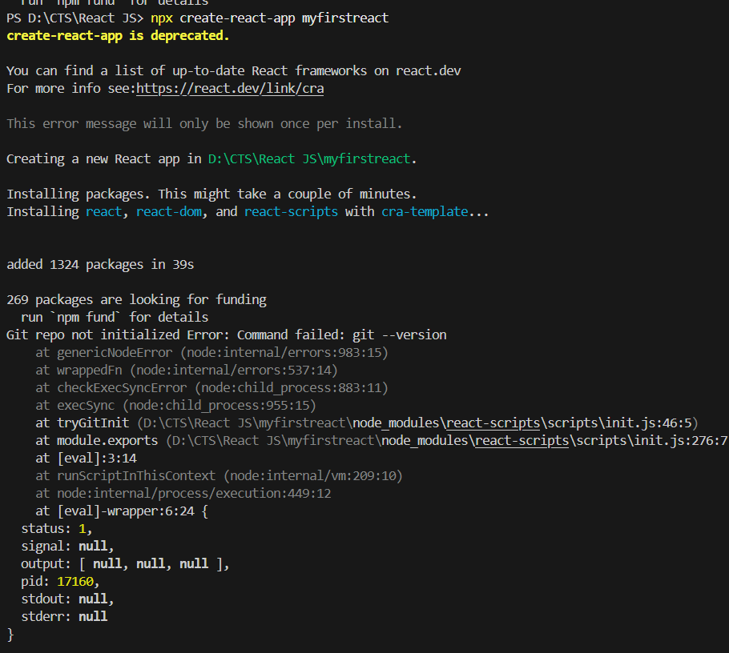

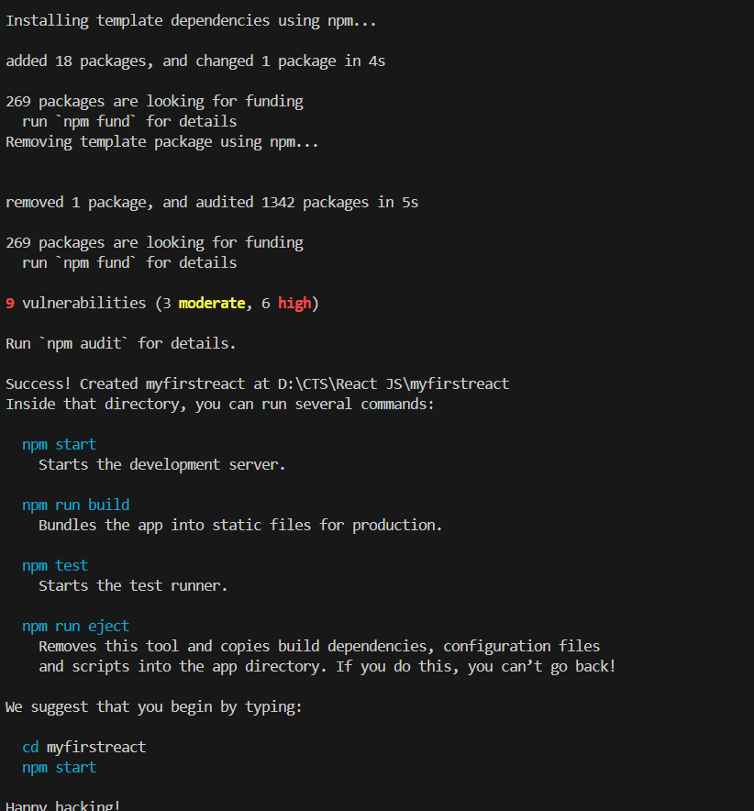

1. Once the App is created, navigate into the folder of myfirstreact by typing the following command:

**cd myfirstreact**

**npm start**

**Output:**

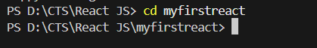

1. Open the folder of myfirstreact in Visual Studio Code

**Output:**  
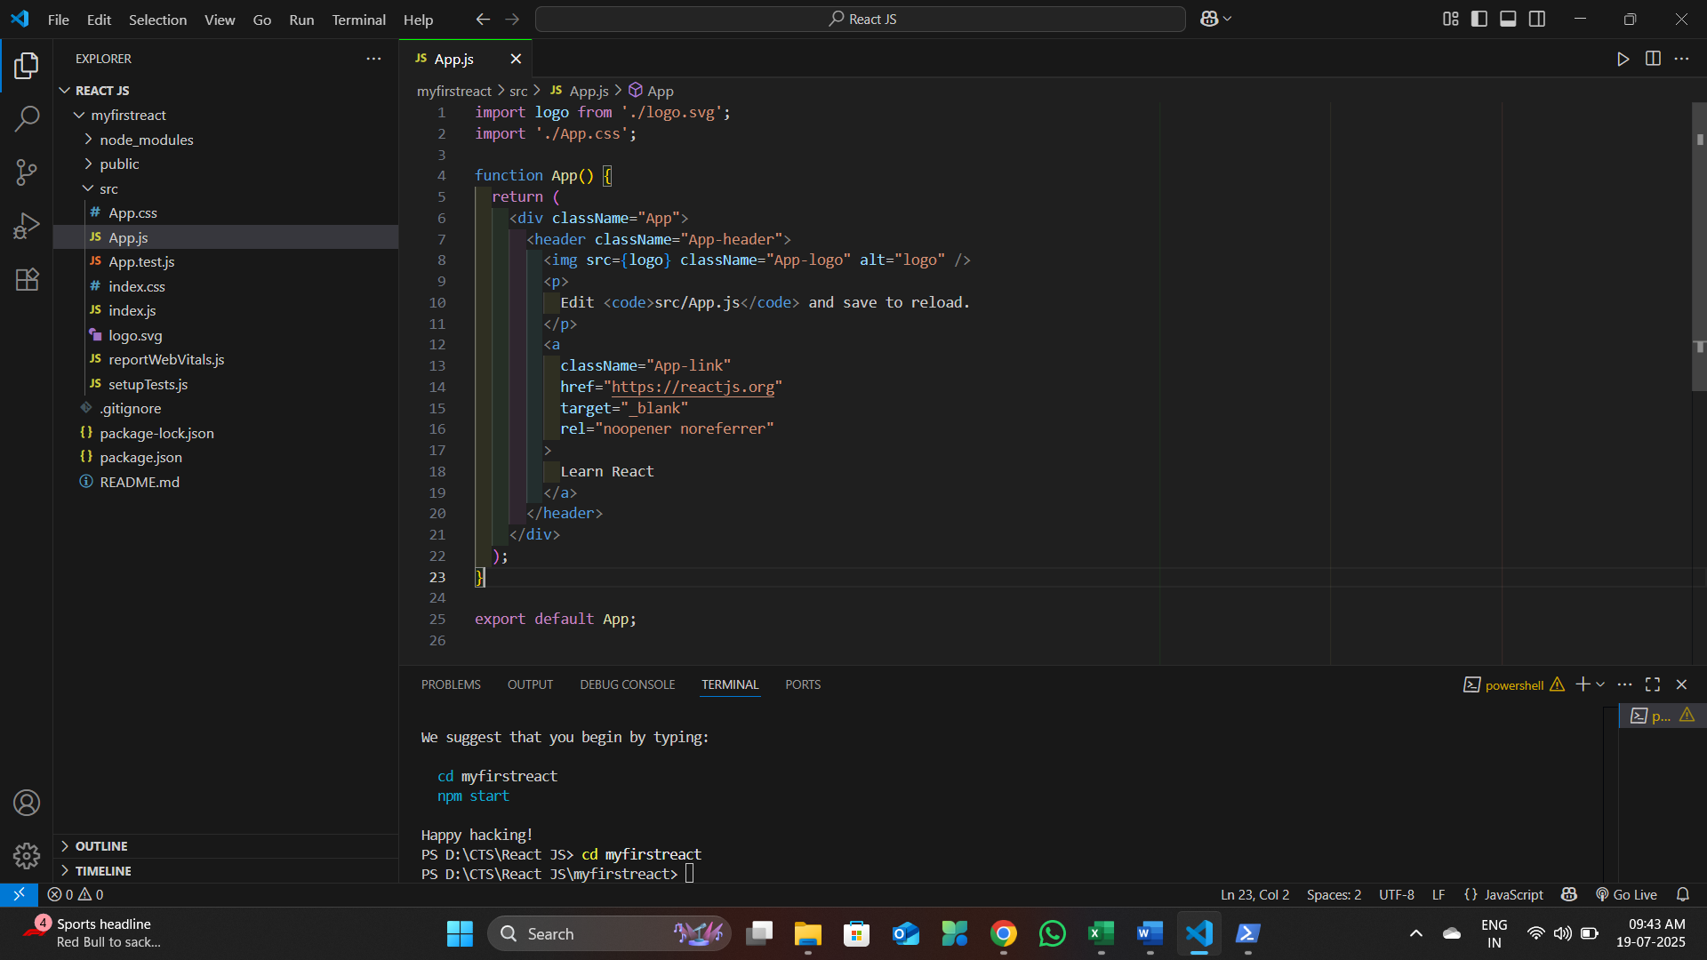

1. Open the App.js file in Src Folder of myfirstreact
2. Remove the current content of “App.js”
3. Replace it with the following:

**Code :**

import logo from './logo.svg';

import './App.css';

function App() {

  return (

    <h1>Welcome to the first session of React App!!!!!!!</h1>

  );

}

export default App;

**Output:**

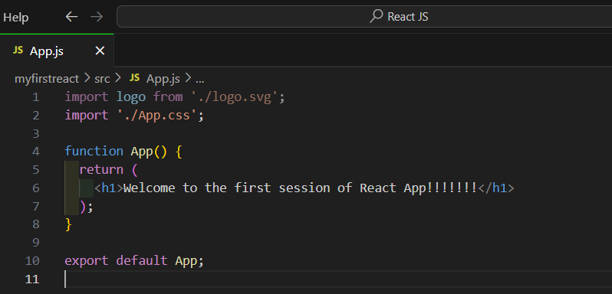

1. Run the following command to execute the React application:

**npm start**

**Output:**  
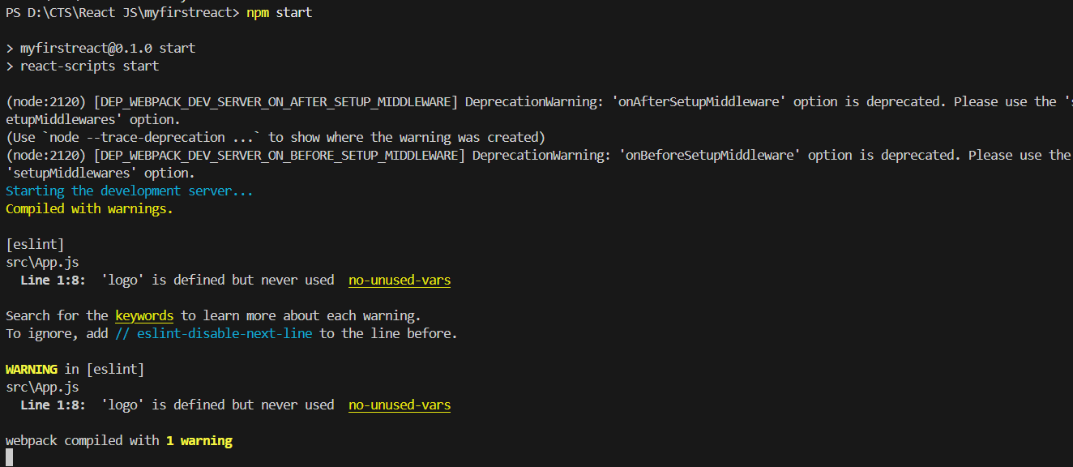

1. Open a new browser window and type “localhost:3000” in the address bar

**Output:**

